1. Locate the Crossfuze – ObserveIT X.X.xml file on your file system.
2. Navigate to ‘System Update Sets -> Retrieved Update Sets’ in your Service-now instance and click the ‘Import Update Set from XML’ link at the bottom of the list

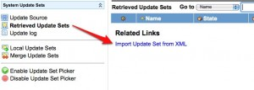

1. Browse to the update set XML file that you extracted in step 1 and click the ‘Upload’ button

[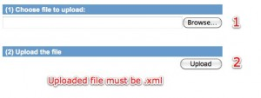](http://www.servicenowguru.com/wp-content/uploads/2010/03/importUpdateSet2.jpg)

1. Once the update set has been uploaded, open the ‘Retrieved Update Set’ record and click the ‘Preview Update Set’ button. Let the preview finish and then review the information or return to the update set.  
     
   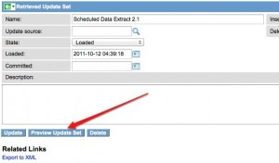
2. Once the update set has been previewed, open it and click the ‘Commit Update Set’ button. This process may take a while depending on the size of the update set you are committing. Once the process is finished, you will see a confirmation message as shown below.

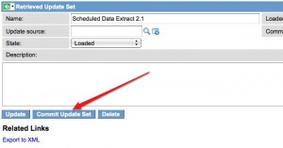  
  
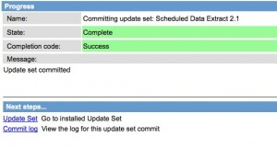

1. Your ObserveIT integration product is ready to use! You may need to refresh your browser to see the new Integration - ObserveIT application and its modules.

